**Banking Management System -**

1. Current Bank System, stores all Loan Account Transactions, Mortgages in a offline manner in docs and spreadsheets.
2. To view a customer transaction and multiple loan transactions we need to search the papers for each of its loan transaction and that consumes a lot of time.
3. Also all the Customers data is  stored offline and different types of accounts are stored in different places, making it difficult to manage and also serve customers.
4. Managing Employees and Bank branch data is difficult as the data is only physically available and confined to respective branch making it less resilient.

**Tables**

**Person** -

* personId - PK - Integer NOT NULL
* firstName - Varchar(50) NOT NULL
* lastName - Varchar(50) NOT NULL
* Email - Varchar(50) NOT NULL
* Contact - Int(10) NOT NULL
* Dob- DateTime NOT NULL
* taxResidentNumber - Varchar(12) NOT NULL
* Address - Varchar(100) NOT NULL
* City - Varchar(50) NOT NULL
* State - Varchar(50) NOT NULL
* ZipCode - Varchar(50) NOT NULL

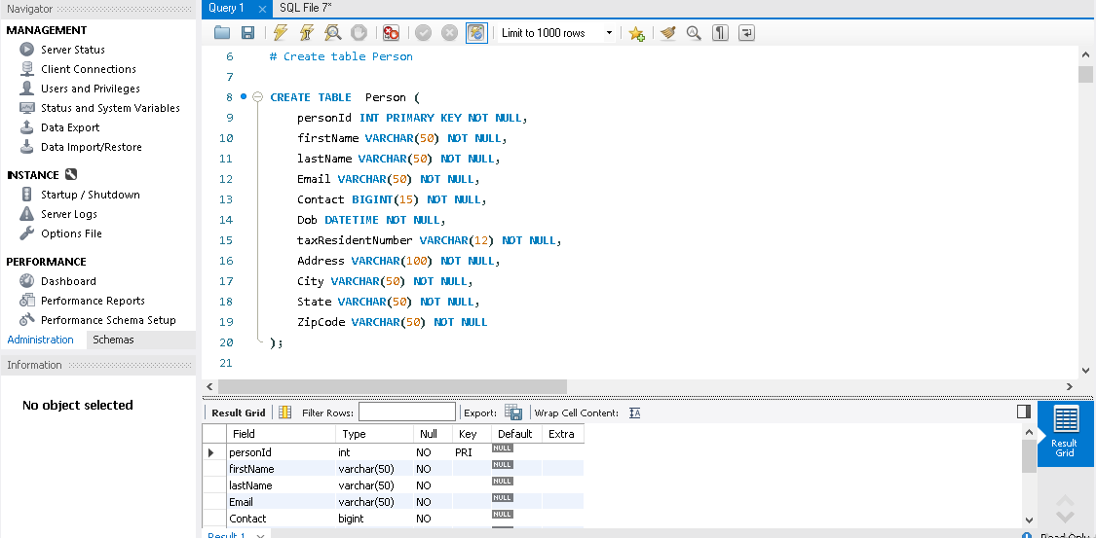

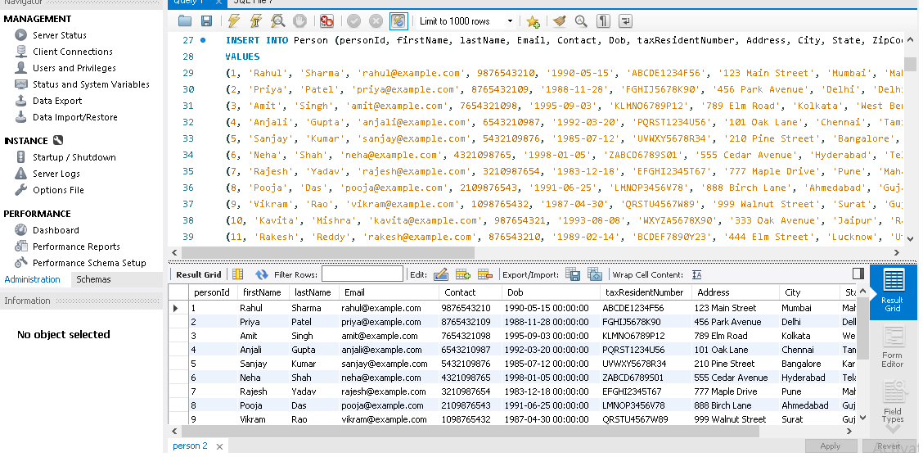

**Branch** -

* branchId - PK - INT NOT NULL
* branchName - VARCHAR(50) NOT NULL
* branchCode - VARCHAR(10) NOT NULL
* Address - Varchar(100) NOT NULL
* City - Varchar(50) NOT NULL
* State - Varchar(50) NOT NULL
* ZipCode - Varchar(50) NOT NULL
* Email - Varchar(50)
* Contact - Int(10) NOT NULL

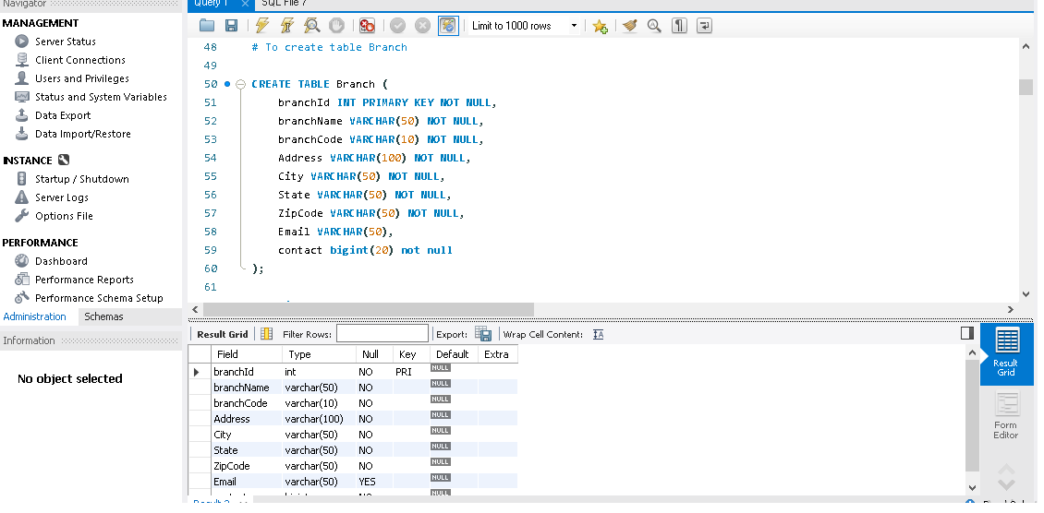

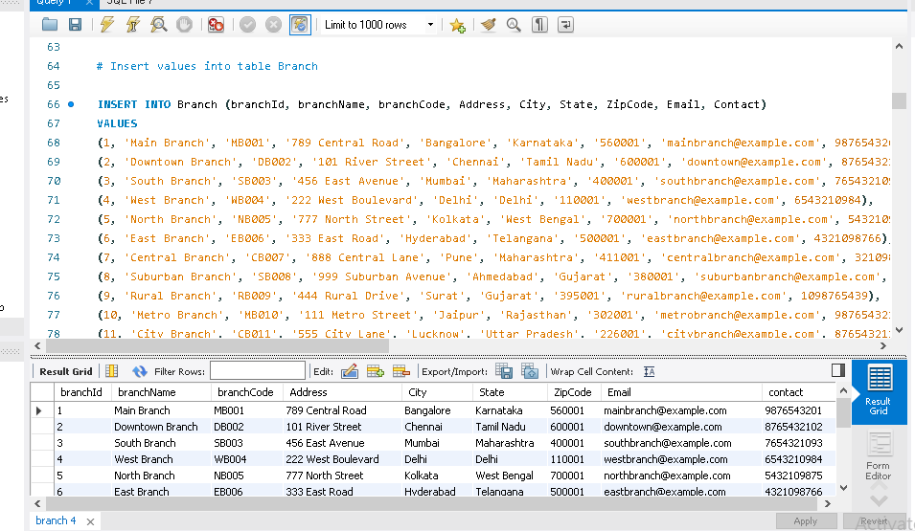

**Department** -

* departmentId - PK INT NOT NULL
* departmentName- VARCHAR(50)
* departmentCode - VARCHAR(10)
* departmentType - VARCHAR(20) [ACCOUNTS, SALES, MANAGEMENT, CRM]

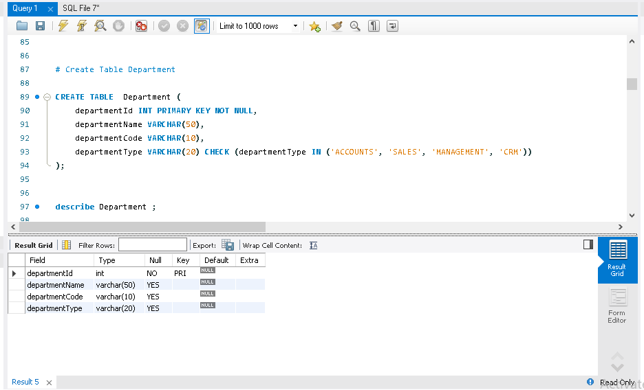

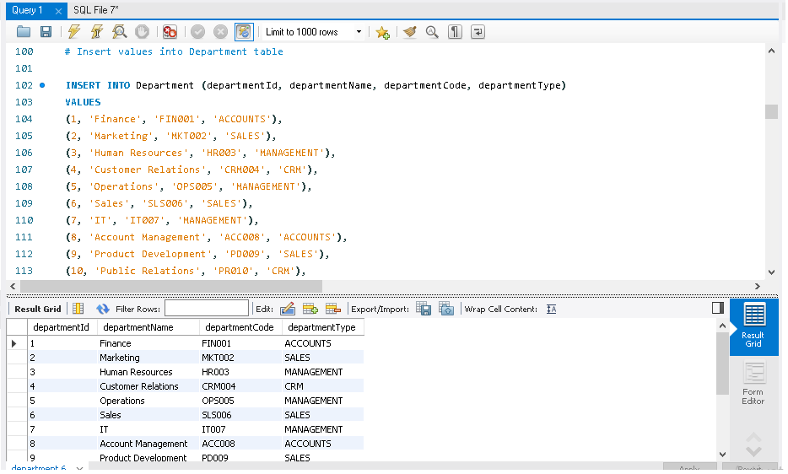

**Customer -**

* customerId - FK - Integer Not Null UNIQUE (this will be FK with personID of Person table)
* customerType  - Varchar(50) [REGULAR, PREMIUM]
* branchId - FK - Int Not Null with branchId of Branch Table
* accountId - FK with accountId of Account table (can be NULL as Customer may or may not have an account at Bank)
* referredEmployeeId - FK with employeeId of Employee table ( can be NULL as Employee may not always create account for customer)

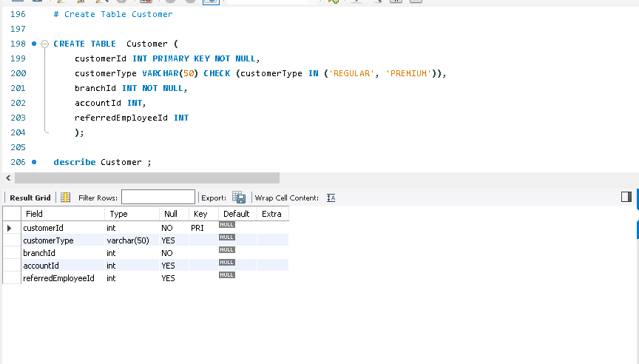

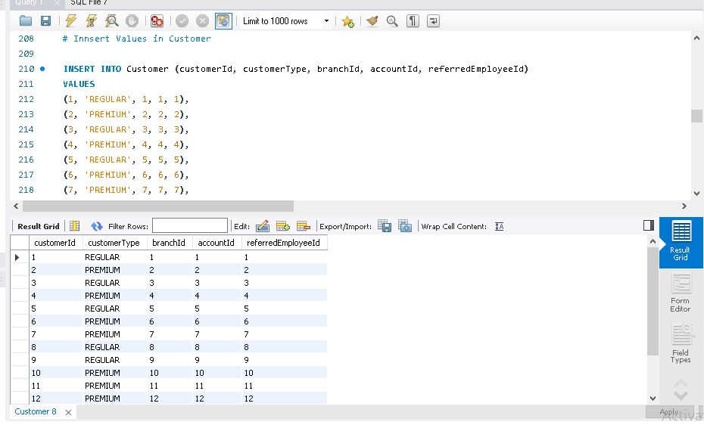

**Employee -**

* employeeId - FK -Integer Not Null UNIQUE (this will be FK with personID of Person table)
* employeeRole - VARCHAR(50) - [MANAGER, EXECUTIVE, ATTENDOR, DIRECTOR]
* hireDate - DATE NOT NULL
* salary - DECIMAL(10,2) NOT NULL
* departmentId - FK - Integer with departmentId of Departments Table
* branchId - FK - Int Not Null with branchId of Branch Table

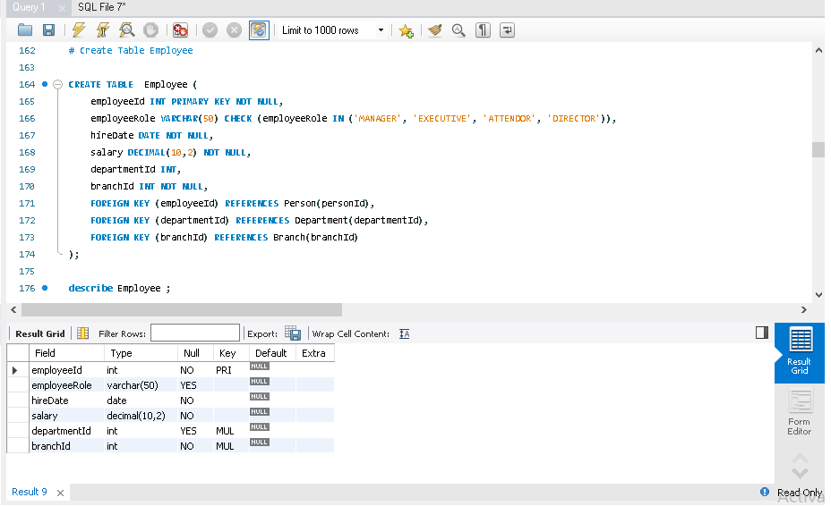

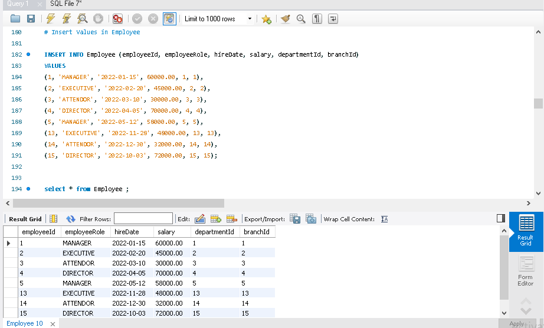

**Account -**

* accountId - PK INT NOT NULL
* accountType - VARCHAR(10) NOT NULL [SAVINGS, CURRENT, JOINT]
* accountNumber - VARCHAR(20) NOT NULL
* currentBalance - DECIMAL(10,2) NOT NULL,  Default - 0.0
* dateOpened - DATETIME NOT NULL
* dateClosed - DATETIME
* accountStatus - VARCHAR(20) , [ACTIVE, CLOSED, SUSPENDED]
* customerId - FK with customerId of Customer table NOT NULL

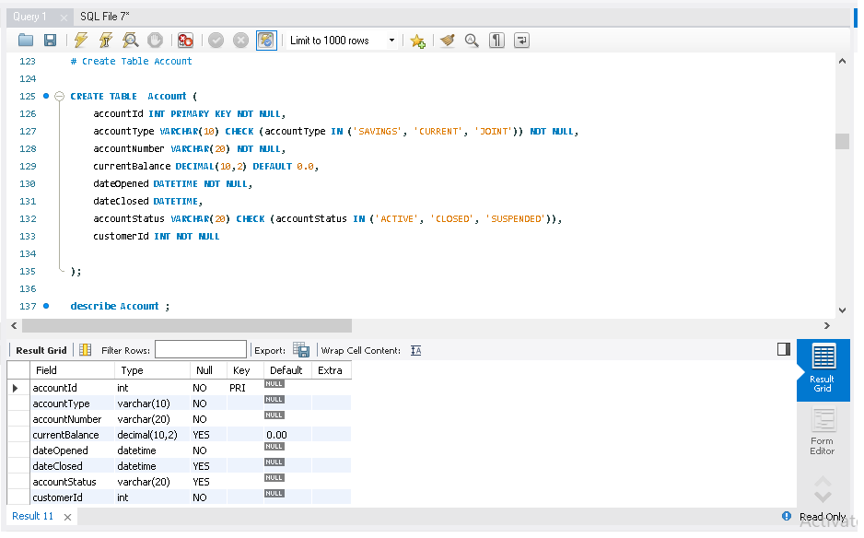

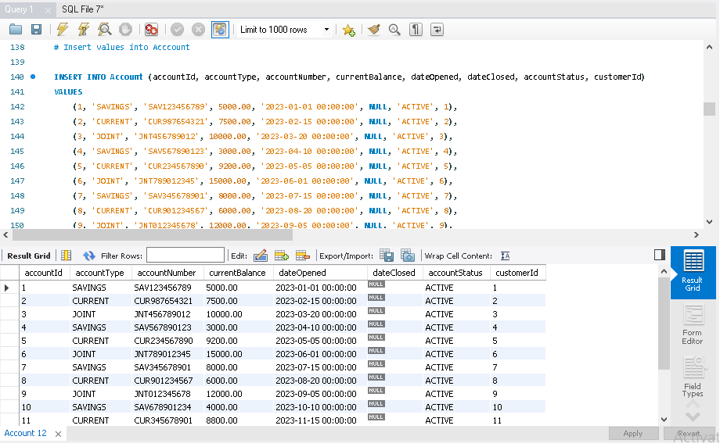

**Loan -**

* loanId - PK INT NOT NULL
* loanType - VarCHAR(50) - [PERSONAL, CAR, EDUCATION, MORTGAGE] NOT NULL DEFAULT VALUE - PERSONAL
* loanTenure - INT(5) - this is in Months NOT NULL
* loanAmount - DECIMAL(10,2) - NOT NULL
* interest - DECIMAL(10,2) - NOT NULL
* loanStart - DATE NOT NULL
* loanEnd - DATE NOT NULL
* loanStatus - VARCHAR(20) - [OPEN, CLOSED, CANCELLED]
* accountId - FK with accountId of Account table

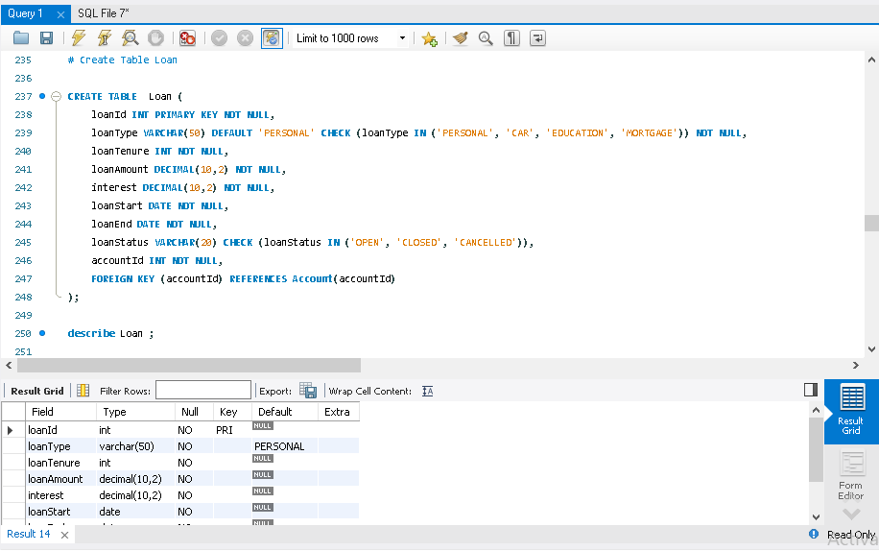

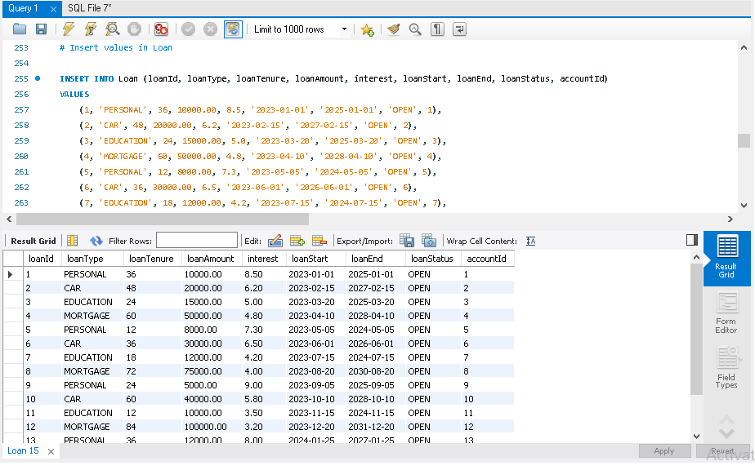

**LoanPayment** - Pre-scheduled Payments of Loan for each Month that tracks whether the customer has paid loan or not for those scheduled dates

* loanPaymentId - PK INT NOT NULL
* paymentDate - DATE NOT NULL
* totalAmount - DECIMAL(10,2) - NOT NULL
* principalAmount - DECIMAL(10,2) - NOT NULL
* interestAmount - DECIMAL(10,2) - NOT NULL
* paidAmount - DECIMAL(10,2)
* paidDate - Date
* loanId - FK with loanId of Loan table NOT NULL

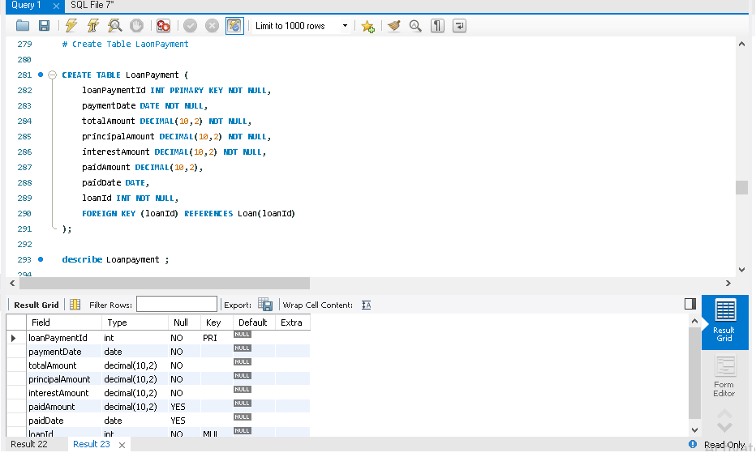

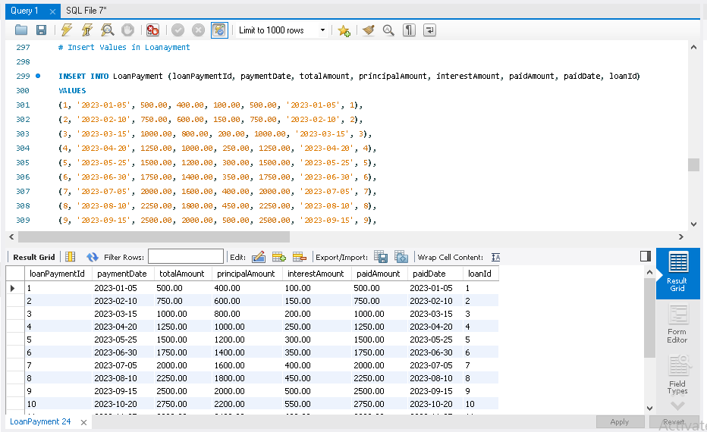

**Transaction Type -**

* transactionTypeId - PK INT NOT NULL
* transactionName - VARCHAR(50) - [DEPOSIT, WITHDRAWAL, TRANSFER] NOT NULL
* description - VARCHAR(100)

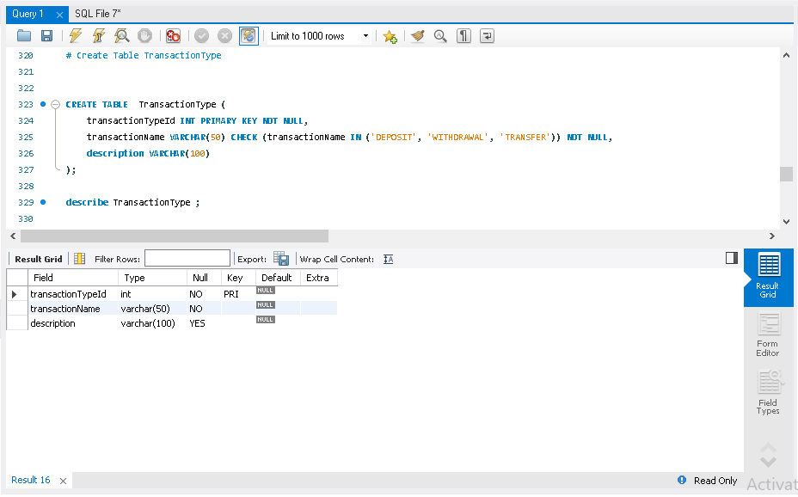

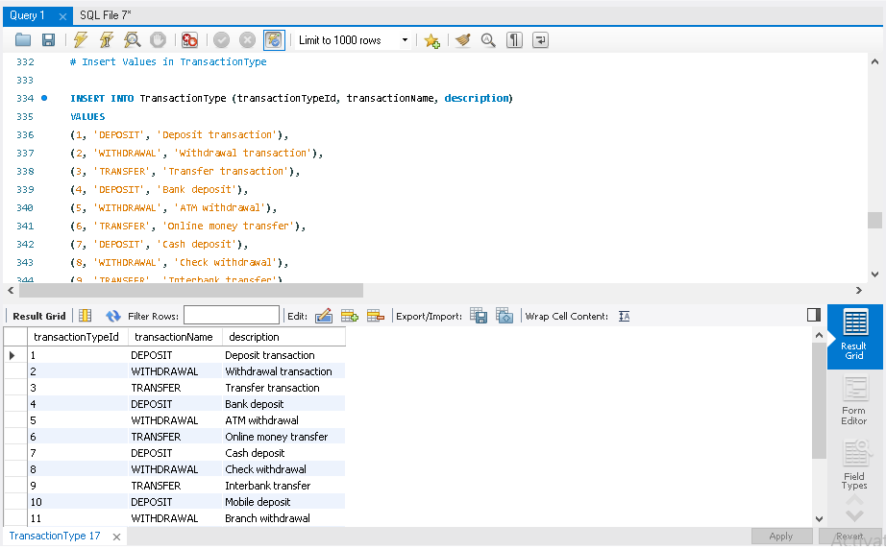

**Transaction -**

* transactionId - PK INT NOT NULL
* transactionAmount - DECIMAL(10,2) NOT NULL
* transactionStat - VARCHAR(10) [CREDIT, DEBIT] NOT NULL
* transactionDate - DATETIME NOT NULL
* transactionTypeId - FK  with transactionTypeId of Transaction Type Payment table
* loanPaymentId - FK  with loanPaymentId of Loan Payment table (A transaction can happen for loan payment)
* accountId - FK with accountId of Account Table ( A transaction can be done by an Account which is a Customer)
* employeeId - FK with employeeId of Employee Table ( A transaction can be done by an Employee of Bank)

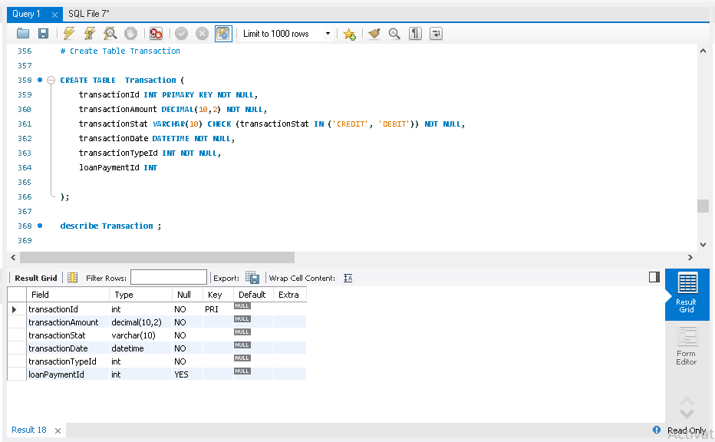

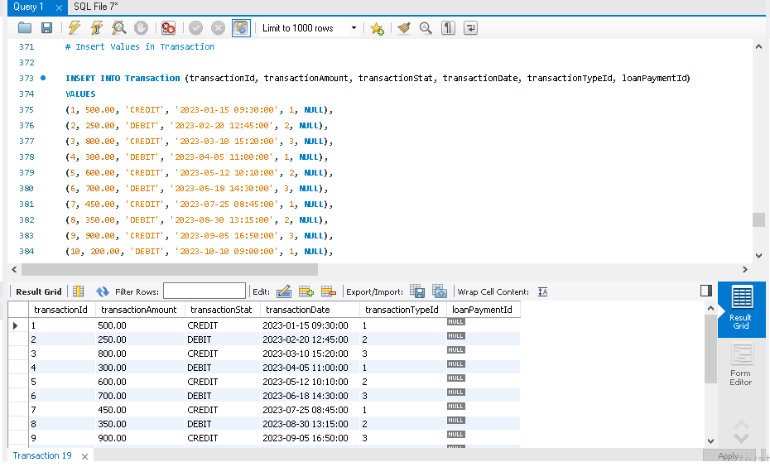

**FailedTransaction -**

* failedTranId - PK INT NOT NULL
* errorMessage - VARCHAR(100)
* transactionId - FK with transactionId of Transaction table NOT NULL

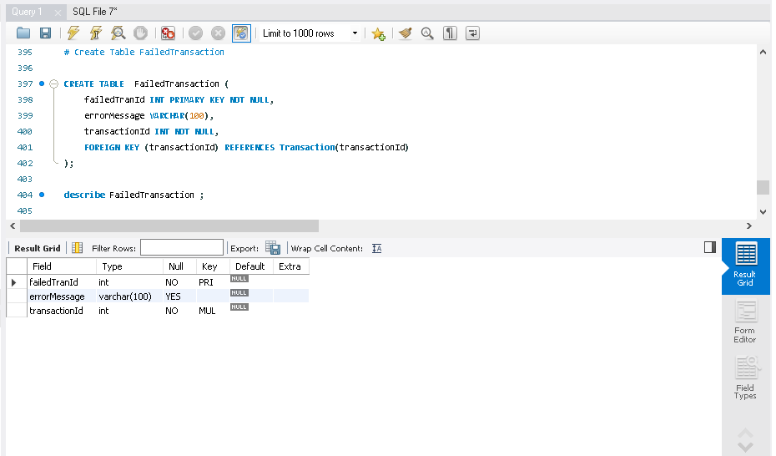

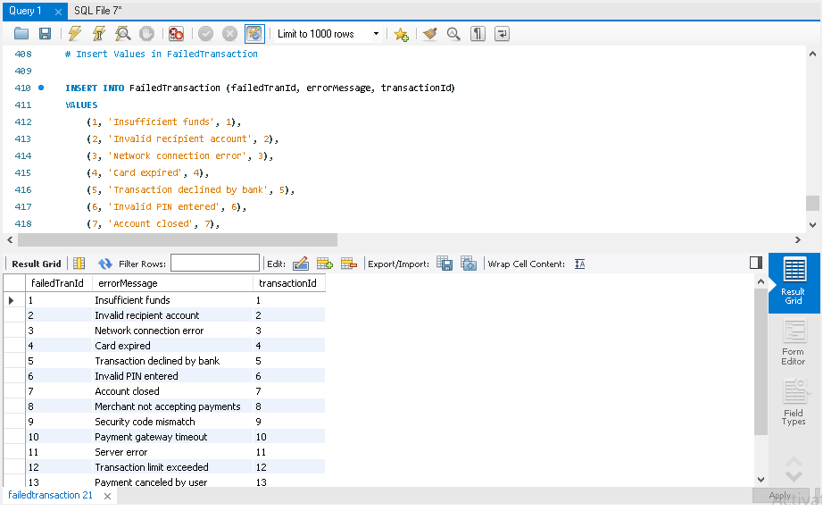

**RelationShips** -

* Person -> Customer - 1:1 relation
* Person -> Employee - 1:1 relation
* Employee -> Customer - 1:M relation
* Department -> Employee - 1:M relation
* Branch -> Customer - 1:M relation
* Branch -> Employee - 1:M relation
* Customer -> Account - M:N relation
* Customer -> Loan - 1:N relation
* Loan -> LoanPayment - 1:N relation
* LoanPayment -> Transaction - 1:N relation
* Account -> Transaction - 1:N relation
* Employee -> Transaction - 1:N relation
* Transaction -> FailedTransaction - 1:N relation